Grade 6
Science

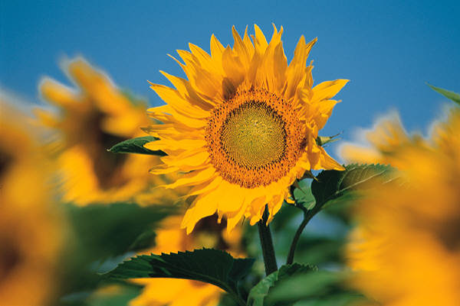

Note to Scholar and Parents/Guardians

This is an at-home science instructional packet for 6th grade scholars during the time LMCJ is closed March 16th-March 27th due to coronavirus.

This packet has been created to provide practice for scholars to answer Selected Response (SR) items and work through technical reading passages of informational text to write Constructed Responses (CRs) to support middle school science. For Constructed Response items, it is highly recommended that scholars practice their annotating skills when reading the text.

Scholars will use the passages to write claims, evidence, and reasoning for Constructed Response items and circle the correct answer choice for Selected Response items.

Science and Engineering Practices

Use the information below to answer Number 1.

Ms. Castillo wanted to know if she gave peppermints to her students before the test if it would increase their test scores. She gave all the students peppermints before Test A and gave them water before Test B. Ms. Castillo analyzes the data from both tests and saw that the scores were higher in Test B.

1. What conclusions can be drawn about the results from Ms. Castillo’s investigation?

- The students should drink water before the test.

- The students should drink water with a peppermint before the test.

- The investigation yielded unreliable results because it had more than one independent variable.

- The investigation yielded reliable results because it had an independent variable and dependent variables.

2. You have run several trials in your experiment and gathered data from each trial.

What will help you organize all the information from your experiment?

- develop a hypothesis

- create a table or a graph

- run some more trials

- draw your conclusion

Use the information below to answer Number 3.

Students counted the number of chirps made at different temperatures in 13 seconds by the same group of snowy tree crickets.

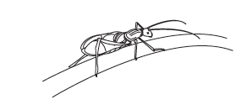
The students recorded the data in the table below. One student concluded that at 22°C there would be 39 chirps.

NUBMER OF CHIRPS

Temperature  (°C) | Chirps per 13 seconds
16 | 20
18 | 24
20 | 28
24 | 35

3. The student’s conclusion is most likely invalid because

- the investigation contains two variables

- the data does not support the reasoning

- the number of crickets studied was too small

- the species of crickets used is not usually studied

Use the information below to answer Number 4.

In general, coastal dolphins seem to be adapted for warm, shallow waters. These dolphins frequently harbor, bays, lagoons, and estuaries. Dolphins that live near the Maryland coastline are often observed in water temperatures between 10° Celsius and 32°Celsius. The number of dolphins counted during several years is shown in the graph below.

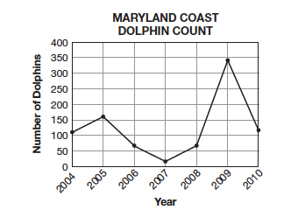

4. Which year most likely had temperatures between 10° Celsius and 32°Celsius for the longest amount of
time?

- 2005

- 2007

- 2009

- 2010

Use the information below to answer Number 5.

Juan did an investigation to determine which brand of batteries lasted the longest in a flashlight. The results are listed below in the graph.

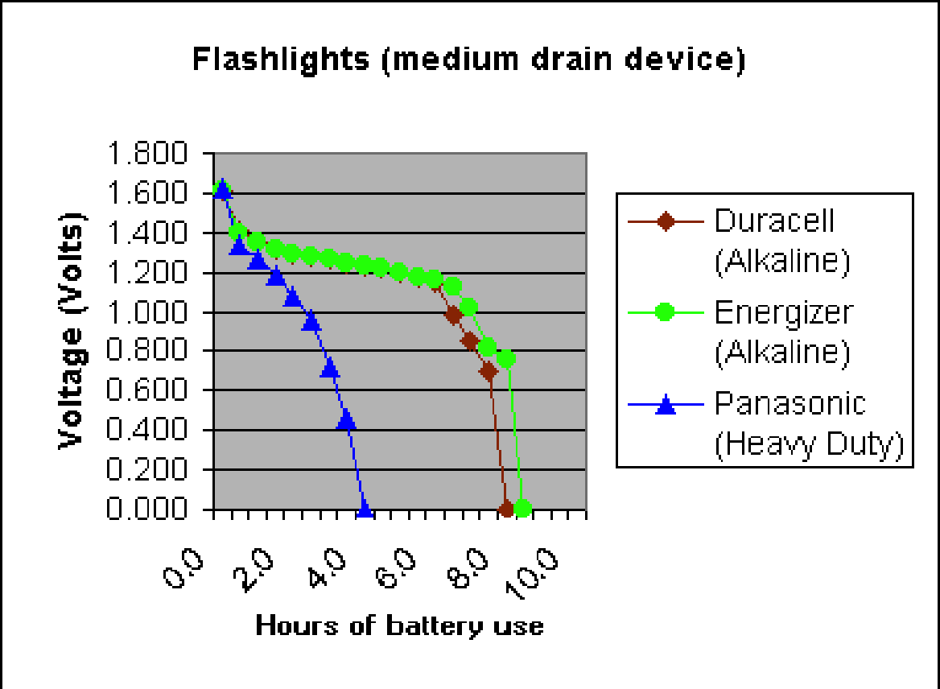

Juan concluded that his hypothesis was supported because the Panasonic battery had the most hours of use. Because the battery was heavy duty, it lasted the longest.

5. Does the data support Juan’s conclusion?

In your response, be sure to include:
- evidence that supports your thinking
- reasons as to why Juan may have come to this conclusion

Write your answer in the space provided.

Use the technical passage below to answer Numbers 6 and 7.

Drilling to the Mantle

In early 2005, scientists working in the Integrated Ocean Drilling Program (IODP) drilled the third deepest hole ever made in the ocean ﬂoor. They were attempting to reach the mantle of Earth. They drilled under water instead of on land because ocean plates are much thinner than continental plates–5 kilometers thick as opposed to 30 kilometers thick.

The IODP drilling occurred at the Atlantis Massif, a large dome-shaped area in the North Atlantic Ocean that is about 16 kilometers wide. In this area, the crust is very thin and the ocean is shallow, making the project easier. Seismic data were used to choose the location of the thinnest crust. This area is characterized by metamorphic rock deposits. Unfortunately, scientists think the drilling occurred about 305 meters from the correct location. Although rock was recovered from up to 1,416 meters below the sea ﬂoor, the mantle was not reached. There were still useful results, however. One scientist said that the rock collected was from some of the deepest sections of the crust ever reached. These rocks will give geologists a chance to learn more about how the crust was formed.

Rocks brought to the surface from deep in the crust of Earth help geologists better understand the structure of the planet and how it formed. Early ideas about the evolution of Earth are being revised because of these new rock samples.

Scientists know that mantle material is very different from crust material. For example, mantle rock has a different texture and composition than crust material. The amount of minerals in the crust also is different from the amount of minerals in the mantle.

6. The scientists working at the Integrated Ocean Drilling Program are most likely

A. researching the structure of the planet.

B. looking for more information about ocean food webs.

C. investigating how ﬁsh live in the depths of the ocean.

D. trying to understand how the ocean inﬂuences weather.

7. The Integrated Ocean Drilling Program scientists hypothesized that drilling at the Atlantis Massif would allow scientists to collect rocks from the mantle of Earth.

Explain why scientists make a hypothesis. In your explanation, be sure to include:

- the importance of a hypothesis
- what might be learned from an incorrect hypothesis
- supporting evidence from this investigation

Write your answer in the space provided.

