Grade 7
Science

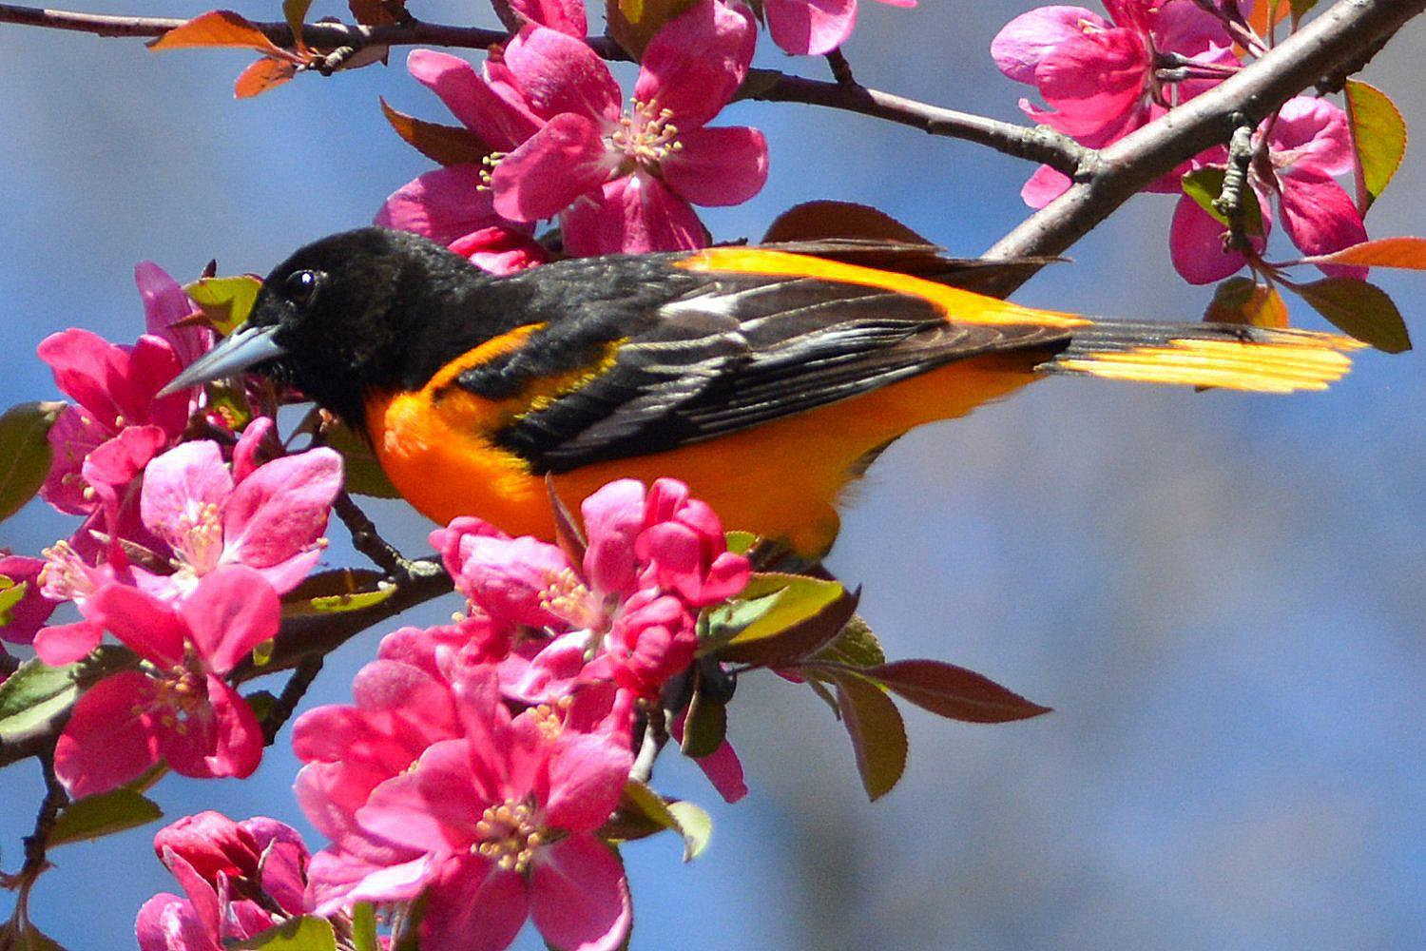

Note to Scholar and Parents/Guardians

This is an “at-home” science instructional packet for your 7th grade scholar while we are closed due to Coronavirus from March 16th-March 27th.

This packet has been created to provide practice for scholars to answer Selected Response (SR) items and work through technical reading passages of informational text to write Constructed Responses (CRs) to support middle school science. For Constructed Response items, it is highly recommended that scholars practice their annotating skills when reading the text.

Scholars will use the passages to write claims, evidence, and reasoning for Constructed Response items and circle the correct answer choice for Selected Response items.

Science and Engineering Practices

Use the information below to answer Number 1.
- Grace's class measured the temperature outside four times a day for four days in a row. Their results are shown below.
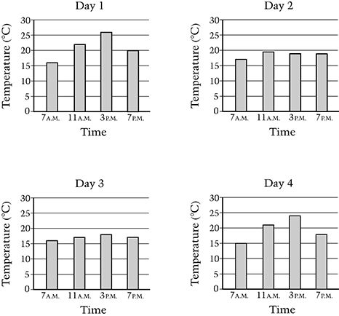
Based on these data, which two days were most likely cloudy?

- Days 1 and 2

- Days 2 and 3

- Days 3 and 4

- Days 1 and 4

2. You have run several trials in your experiment and gathered data from each trial.

What will help you organize all the information from your experiment?

- develop a hypothesis

- create a table or a graph

- run some more trials

- draw your conclusion

Use the information below to answer Number 3.

Rafael lives near a road at the bottom of a hill. His parents are concerned that soil will wash off the hill and rocks will fall onto the road. Rafael conducts an investigation to find out if grass growing on a hillside will help stop soil erosion. He collects two samples of the same size and type of soil. One sample of soil has grass growing on it and the other does not. He places each sample of soil in a small tray.

After pouring the water onto both pieces of soil, Rafael makes an observation. The water collected in the tray under the soil with grass looks clearer than the water collected in the tray under the soil without grass.

3. What conclusion can Rafael make from his observation?

- The grass helped to hold the soil in place.

B. The grass helped to move the water through the soil.

C. The soil without grass was sticky, so more water stayed in the soil.

D. The soil without grass was loose, so more water stayed in the soil.

Use the information and table below to answer Number 4.

4. You are helping a friend with a lab report. He tells you that he has discovered that tomato plants grow better in moist soil than in dry soil. You look over the experimental design and see the table below.

Experimental Design

Number of Plants | Soil Type | Garden Location
20 | dry | sunny
25 | moist | part shady

Evaluate your friend’s experimental design.

In your response, be sure to include:

- the list of variables in the experiment
- validity of your friend’s conclusion
- a description on how you would change the experiment

Write your answer in the space provided.

Use the information and table below to answer Number 5.

5. Two students investigated the growth of pea plants. Each student had three pots. All of the pots contained the same type and amount of soil. They planted pea seeds in each pot. The students set up their investigations as shown in the table below.

Explain which student had the best setup to find out how the amount of sunlight affects the growth of pea plants.

In your response, be sure to identify the independent and dependent variables.

Student Name | Volume of Water  Added to Pots | Temperature of  the Environment | Amount of Sunlight Pots Received
Michael | The same for each pot | Different for each pot | The same for each pot
Carmen | The same for each pot | The same for each pot | Different or each pot

Write your answer in the space provided.

Use the diagram below to answer Number 6.

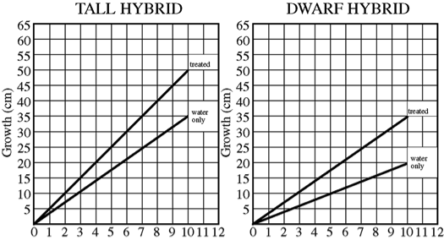

6. In an experiment to study the effect of a new fertilizer on the growth of tall hybrid corn and dwarf hybrid corn, from immediately after germination to ten days of growth, the data above were obtained. Other growing conditions such as water and sunlight were the same for both groups.

Which of the following is the most reasonable conclusion that can be drawn from the data above?

- The new fertilizer influences the growth of both corn varieties tested.

- The new fertilizer causes faster growth rate for both varieties than do other fertilizers.

- The new fertilizer improves the root system of the tall hybrid to a greater extent than it does that of the dwarf hybrid.

- The new fertilizer is effective in producing faster growth for both varieties for the first ten days only.

