Grade 8
Science

Note to Scholar and Parents/Guardians

This is a science instructional packet for your 8th grade scholar during this time that we are closed from March 16th- March 27th due to coronavirus.

This packet has been created to provide practice for scholars to answer Selected Response (SR) items and work through technical reading passages of informational text to write Constructed Responses (CRs) to support middle school science. For Constructed Response items, it is highly recommended that scholars practice their annotating skills when reading the text.

Scholars will use the passages to write claims, evidence, and reasoning for Constructed Response items and circle the correct answer choice for Selected Response items.

1. Scientists perform experiments to test hypotheses.

How do scientists try to remain objective during experiments?

  - Scientists analyze all results.

  - Scientists use safety precautions.

  - Scientists conduct experiments once.

  - Scientists change at least two variables.

2. A teacher asks her students the following question: How does the air pressure inside a
soccer ball affect the distance the soccer ball travels after the ball is kicked?

Which statement below is the best hypothesis for this investigation?

- If a soccer ball is large, then the soccer ball will travel a farther distance than a small soccer ball.

- If a soccer ball has a high internal air pressure, then the ball will travel a farther distance than a soccer ball with less internal air pressure.

- If a soccer ball travels a distance of 15 meters, then the ball is traveling faster than a soccer ball that travels a distance of 20 meters.

- If a soccer ball has 0.5 atmospheres of internal pressure, then the ball will travel slower than a ball with 0.8 atmospheres of internal pressure.

3. During an investigation, students were given chemical data for several common
household products, as shown in the data table below. Students were to determine if a
substance was an acid or base by using litmus paper. Litmus paper turns red in an acid
and turns blue in a base.

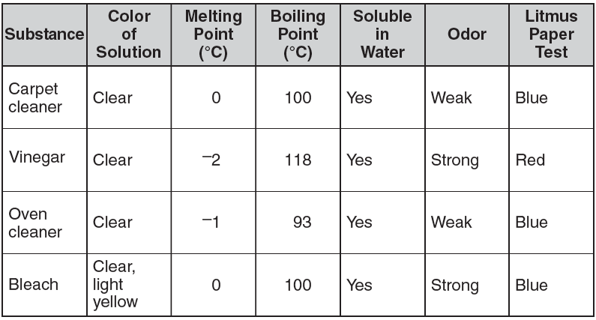

Which conclusion is supported by the data from the investigation?

- Many cleaning supplies are soluble in water.

- Cleaning solutions with a weak odor are acids.

- Water is the main ingredient in many cleaning supplies.

- A substance changes from a gas to a liquid as the temperature of the substance increases.

4. Biologists conduct investigations to learn about living organisms.
Which method helps reduce bias during an investigation?

- developing a hypothesis after collecting data in the investigation

- limiting the amount of background research before the investigation

- designing an investigation with repeated trials during the investigation

- obtaining other opinions concerning what should happen during the investigation

Use the chart below to respond to Number 5.

Effect of Temperature on Length of Onion Cell Cycle
Temperature  (°C) | Length of Cell Cycle  (hours)
10 | 54.6
15 | 29.8
20 | 18.8
25 | 13.3

5. A scientist performed an experiment to determine the effect of temperature on the length of the cell cycle. On the basis of the data in the table above, how long would you expect the cell cycle to be at 5°C?

- less than 12.3 hours

- more than 54.6 hours

- between 29.8 hours and 54.6 hours

- about 20 hours

Use the information and chart below to answer Number 6 on page 7.

Eight students conducted a controlled experiment to demonstrate how walking and running affected their heart rates. Use the data below to answer the following questions.

Effects of Activity on Heart Rate (in beats per minute)

Student | Heart Rate  (at rest) | Heart Rate  (walking) | Heart Rate  (running)
1 | 70 | 90 | 115
2 | 72 | 80 | 100
3 | 80 | 100 | 120
4 | 65 | 75 | 95
5 | 88 | 112 | 125
6 | 74 | 83 | 104
7 | 75 | 88 | 109
8 | 77 | 95 | 130

6. The students came to the conclusion that heart rates raise by 10 to 20 beats per minute
after walking and 20 to 40 beats per minute after running. First, identify the independent
(manipulating) and dependent (responding) variables. Then, explain whether or not the data
table supports this conclusion. In your explanation, be sure to include:

- the manipulated and responding variables
- evidence to support or reject the conclusion given by the students
- any other information that may have been recorded to indicate a controlled experiment or to improve the presentation of the experimental data.

Write your answer in the space provided.

Use the data table below to answer Number 7.

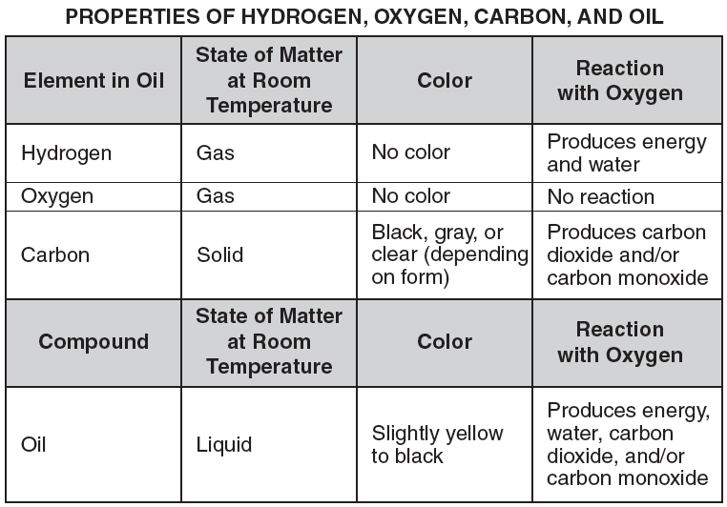

7. Use the space on page 9 to compare the properties of oil to the properties of the
elements in oil.

In your comparison, be sure to include:

• the properties of oil
• the properties of the elements in oil
• the motion of the molecules in oil, carbon, and hydrogen

